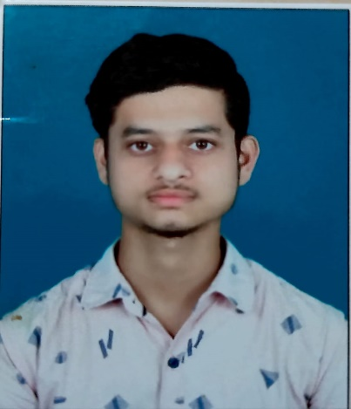**RESUME**

**SOUMYA RANJAN PATRA**

**C/O: - MAHESH PATRA**

**AT: - SERGARH**

**P.O: - SERGARH**

**DIST: - BALESORE**

**PIN: -756060**

**MOB: -6372855100**

**Email ID: -soumyaranjanpatra009@gmail.com**

**CAREER OBJECTIVE: -**

To seek a responsible position, that will give the opportunity for utilizing my potential

And talent to achieve the goal and objectives which will help my personal and professional development.

**ACADEMIC PROFILE: -**

|  |  |  |  |
| --- | --- | --- | --- |
| **COURSE** | **INSTITUTION/UNVERSITY** | **YEAR OF PASSING** | **PERCANTAGE** |
| 10TH | Ranpur Baunsagadia High School, Kupari | 2019 | 72% |
| +2(ISC) | Kalam Higher Secondary School,Soro | 2021 | 77.33% |

**STRENGH: -**

* Comprehensive problem-solving abilities.
* Resources handling capability.
* Adapt easily to new situations.
* Quick learner and always have a positive attitude.
* Good interpersonal skills.

**COMPUTER SKILLS: -**

HTML , CSS , JAVA, JAVASCRIPT,ETC.

**PERSONAL DETAILS: -**

Date of Birth : -25/12/2003

Father’s name : - Mr. Mahesh Patra

Mother’s name : -Mrs. Haripriya Patra

Gender : - MALE

Marital Status : - Unmarried

Religion : - Hindu

Languages Known : - English, Hindi & Odia

Permanent Address : - At – Sergarh, Post – Sergarh, P.S.- Khantapada,

Dist. – Balesore, Pin- 756060, Odisha

**DECLARATION: -**

I hereby declare that the information above furnished is true to the best of my knowledge and belief.

**Place: -Shergada**

Name: -Soumya Ranjan Patra